Teacher Login

1. Username or Password is incorrect
2. Username or Password is Correct

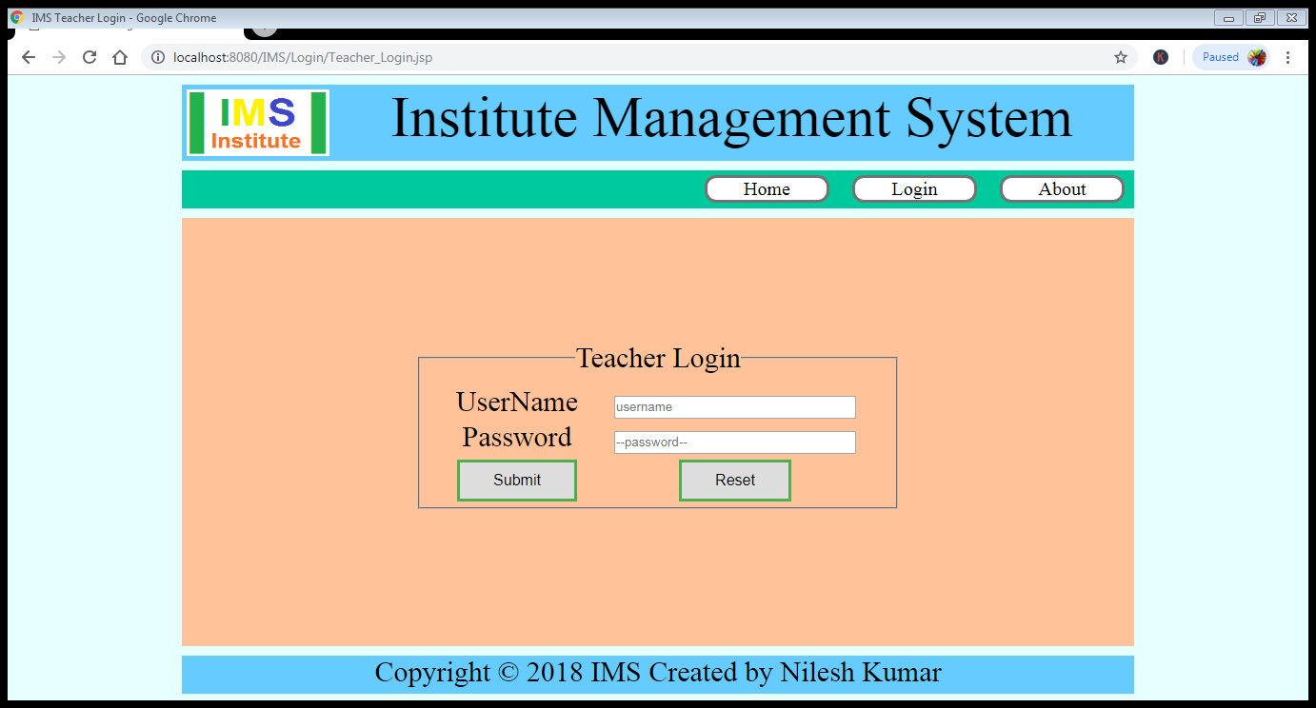

(a) Output When Username or Password is **incorrect** through ConfirmUser.jsp to Teacher_Login.jsp

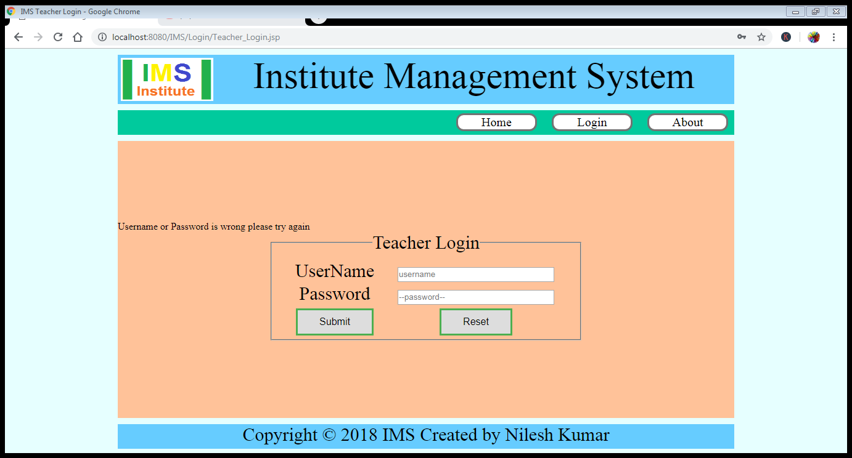

(b) Output When Username or Password is **Correct** through ConfirmUser.jsp to DashBoard.jsp

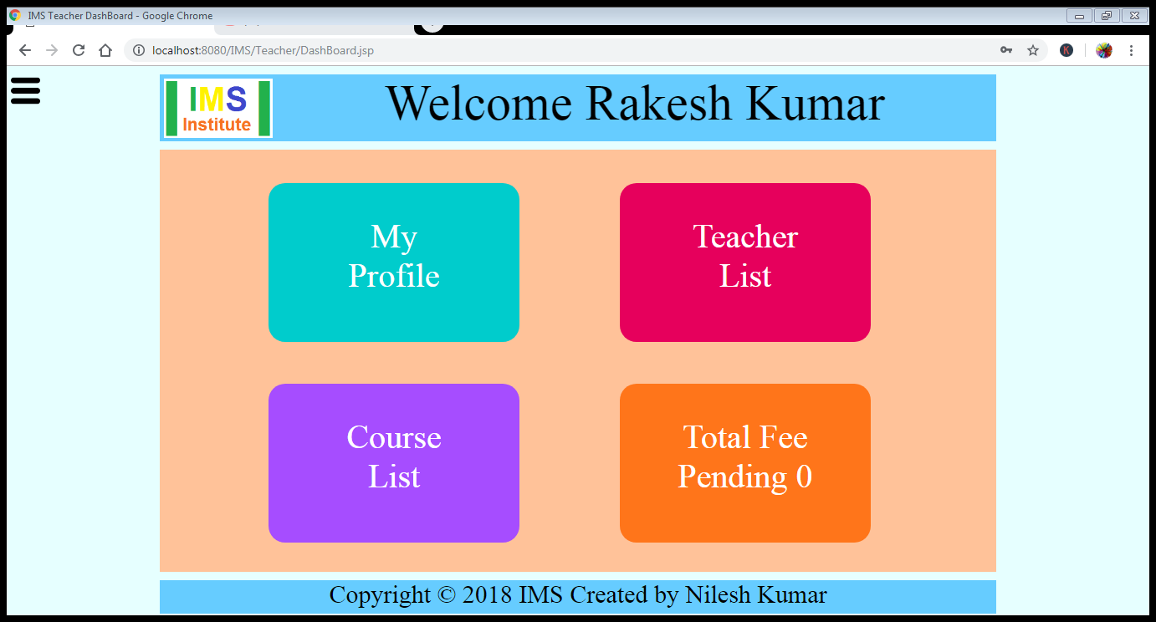

Clicking on My Profile it will open My_Profile.jsp page

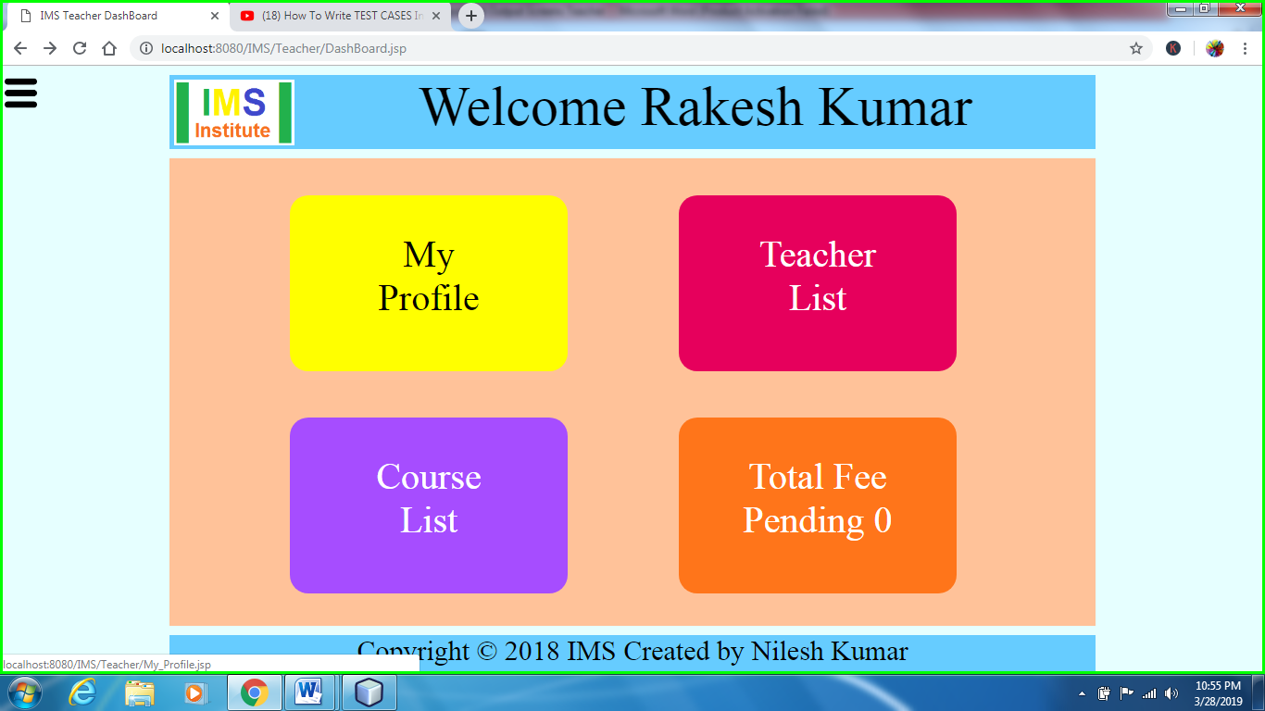

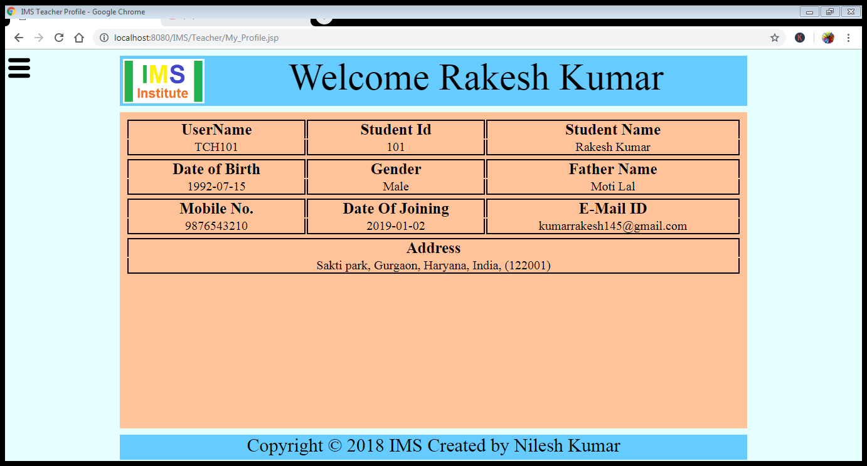

Clicking on Teacher List it will open Teacher_List.jsp page.

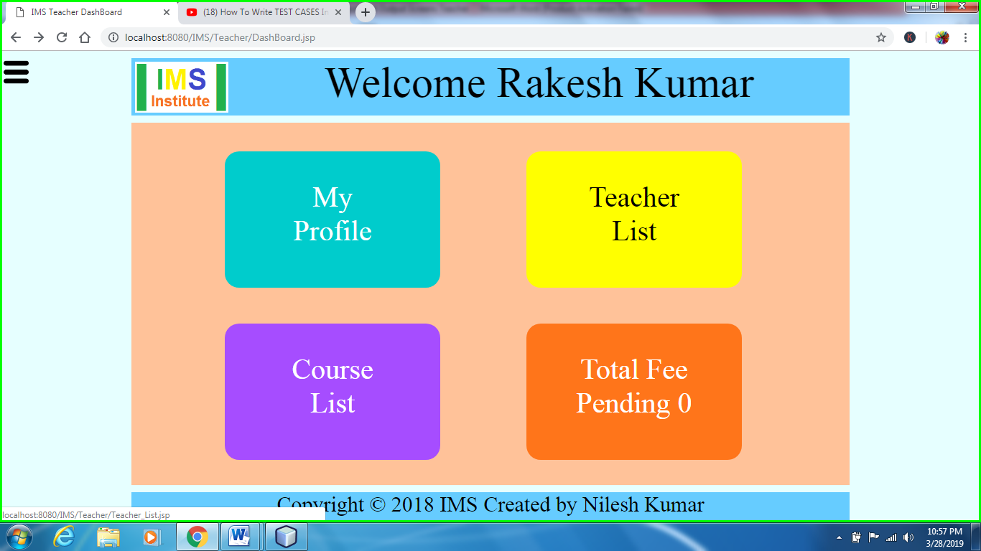

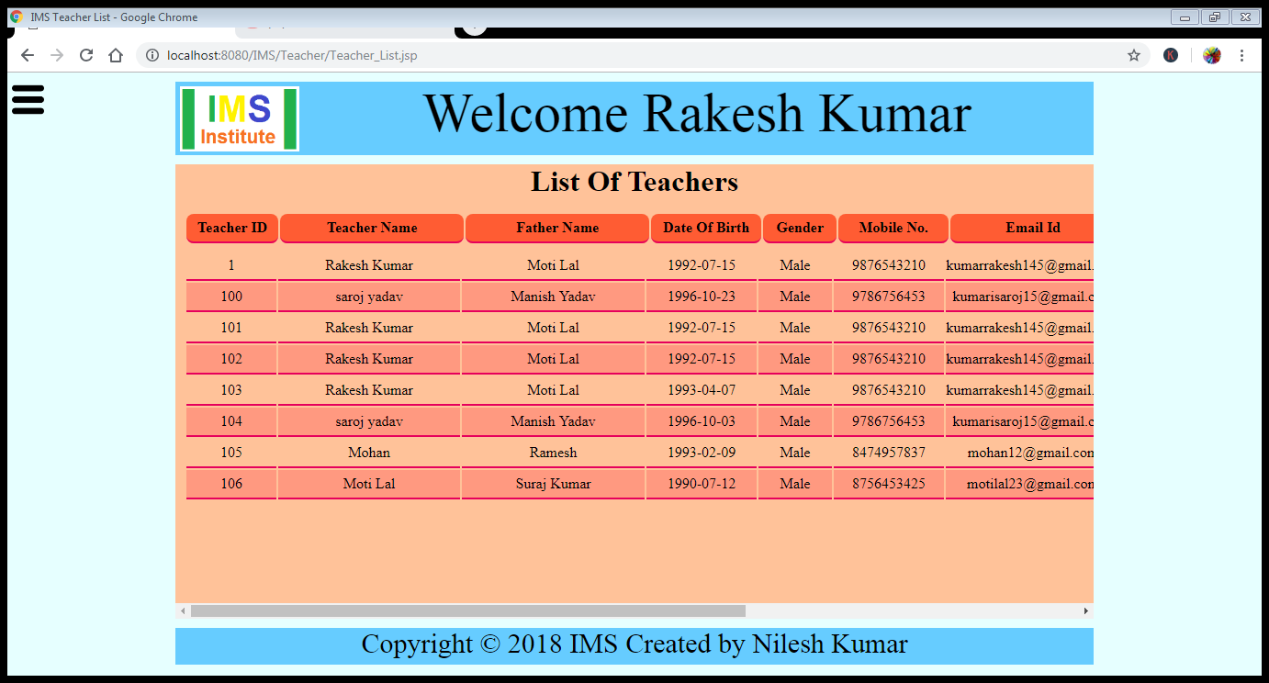

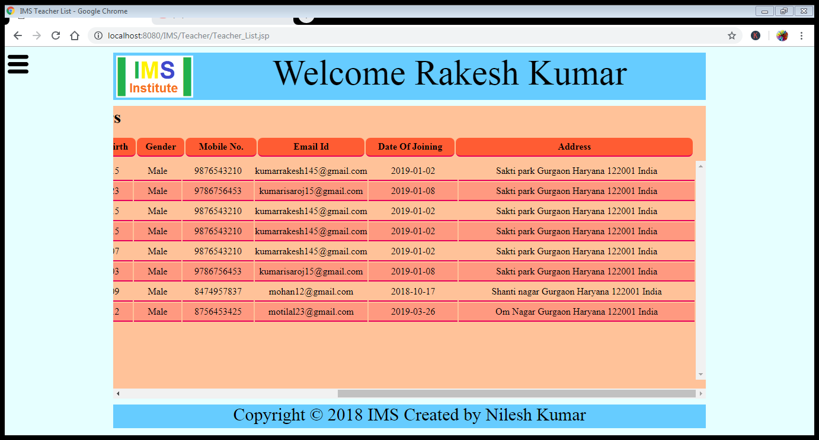

Clicking on Course List and it will open Course_List.jsp page.

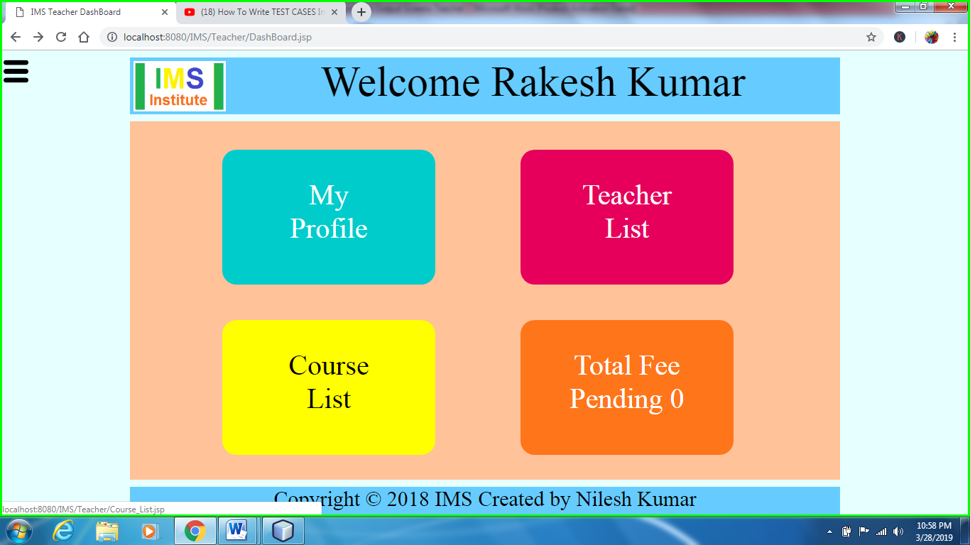

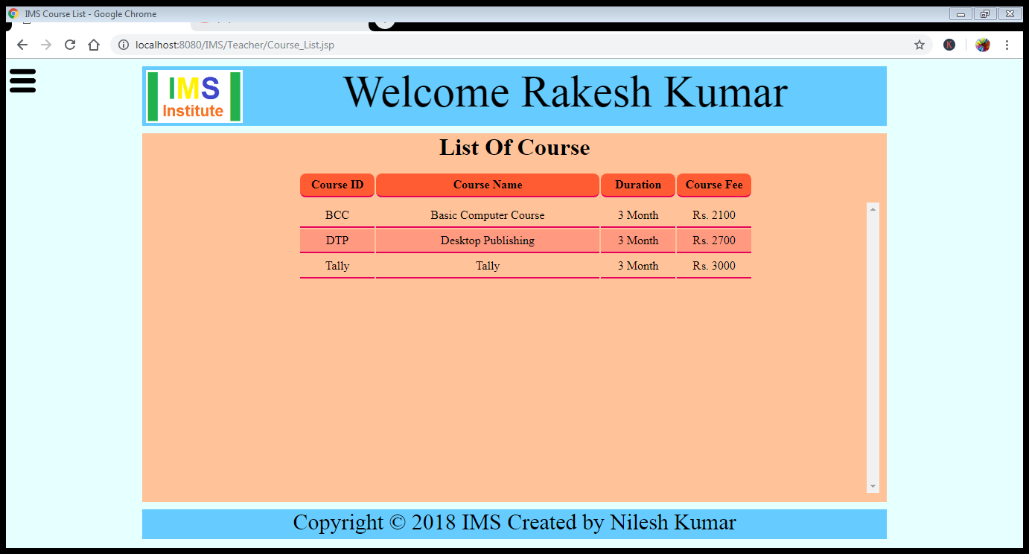

Clicking on total fee pending it will open

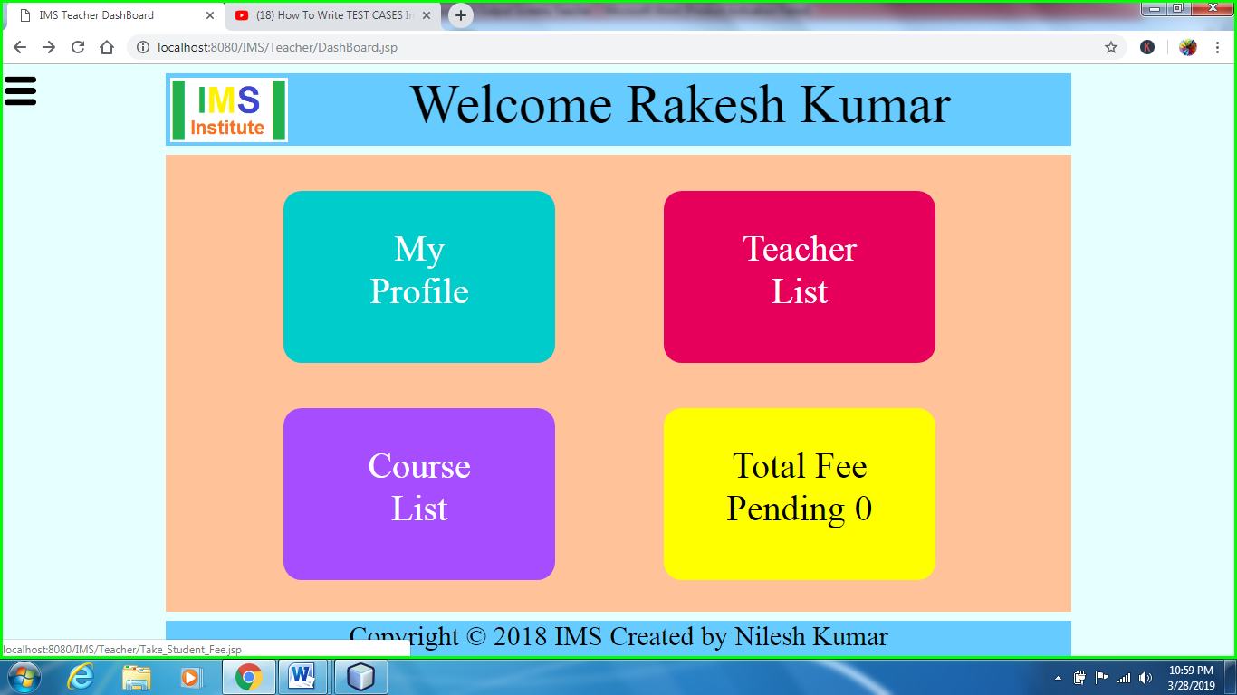

It will display the fee submitted by student

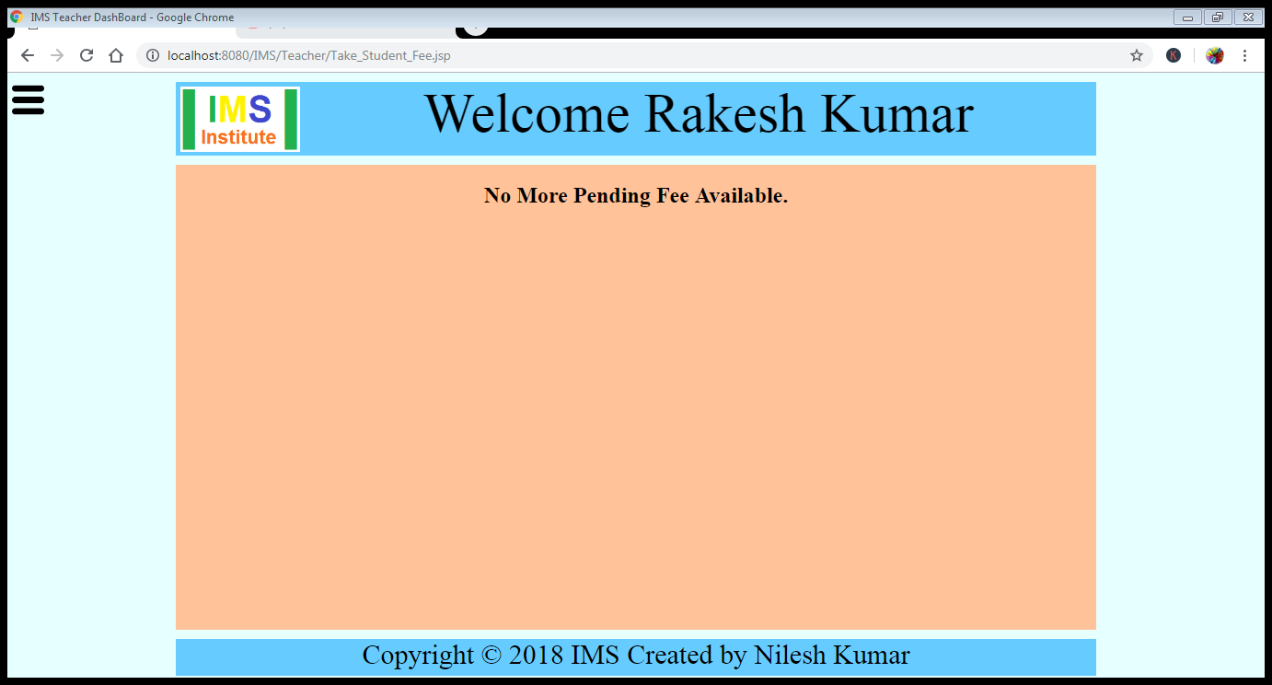

Click on Staff Management (View Teacher List) it will open Teacher_List.jsp page and add detail is already displayed in previous images.

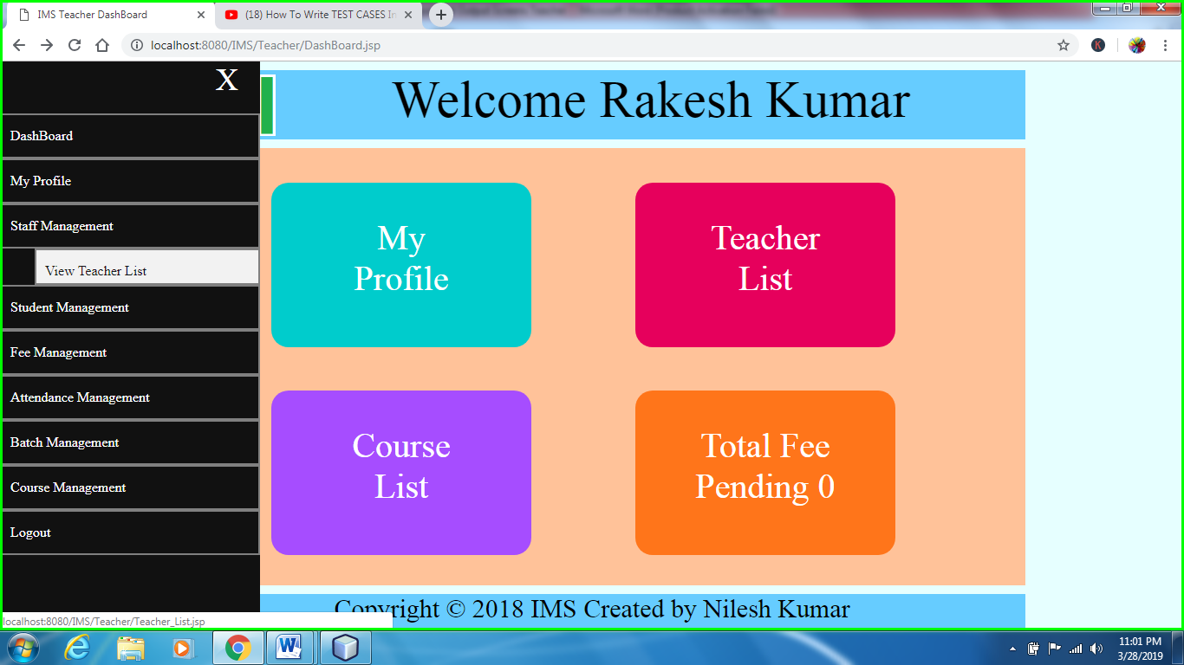

Click on student management (View Student List) it will opens tudent_List.jsp page.

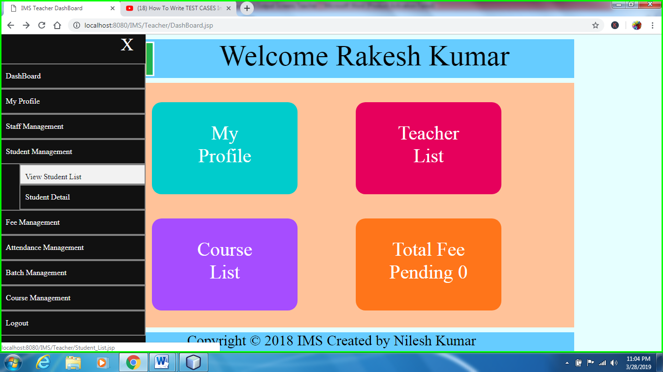

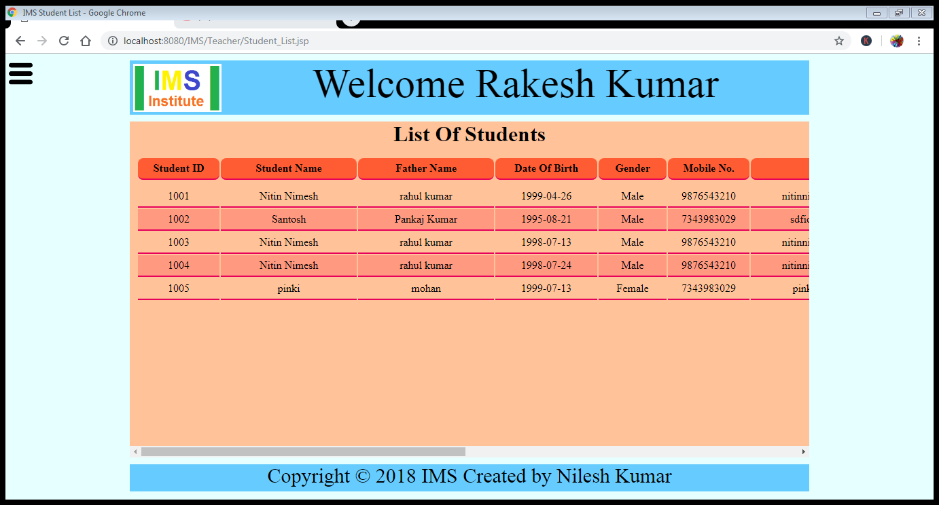

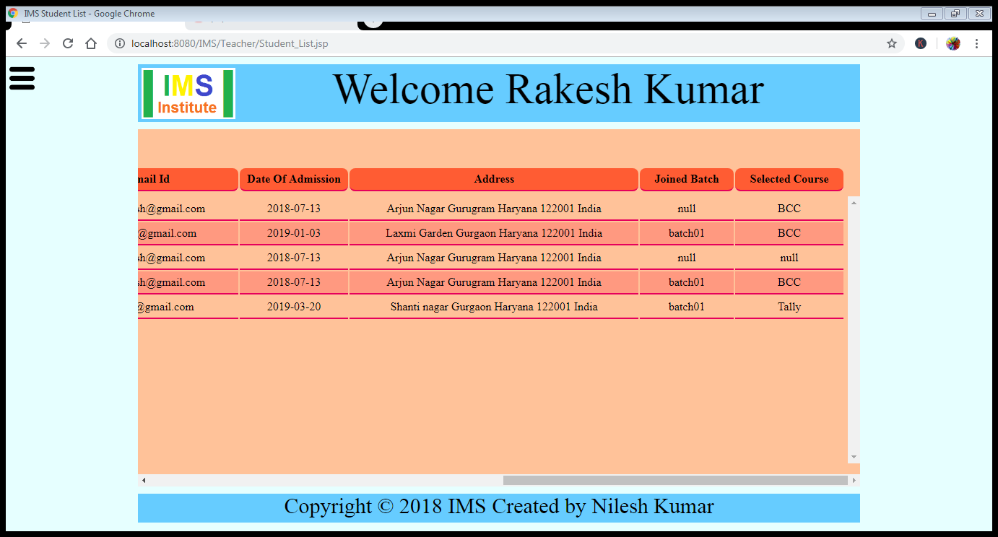

Click on fee management (view student fee report) and it will open tudent_Fee_Report.jsp page

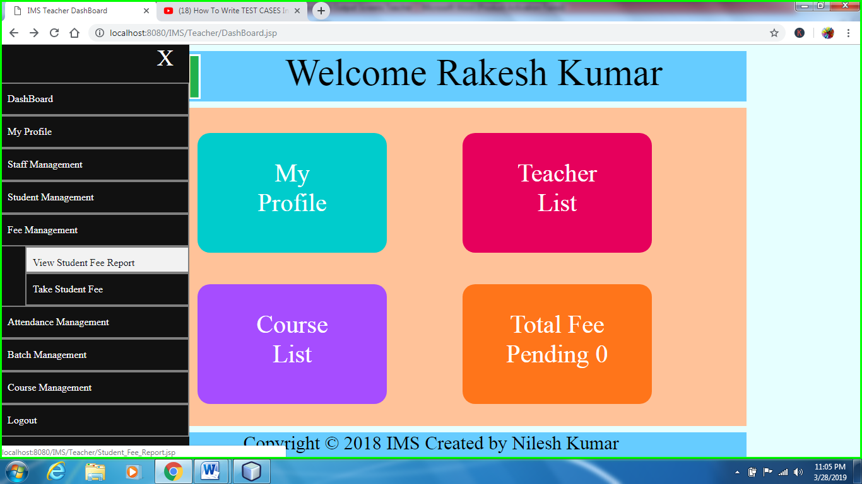

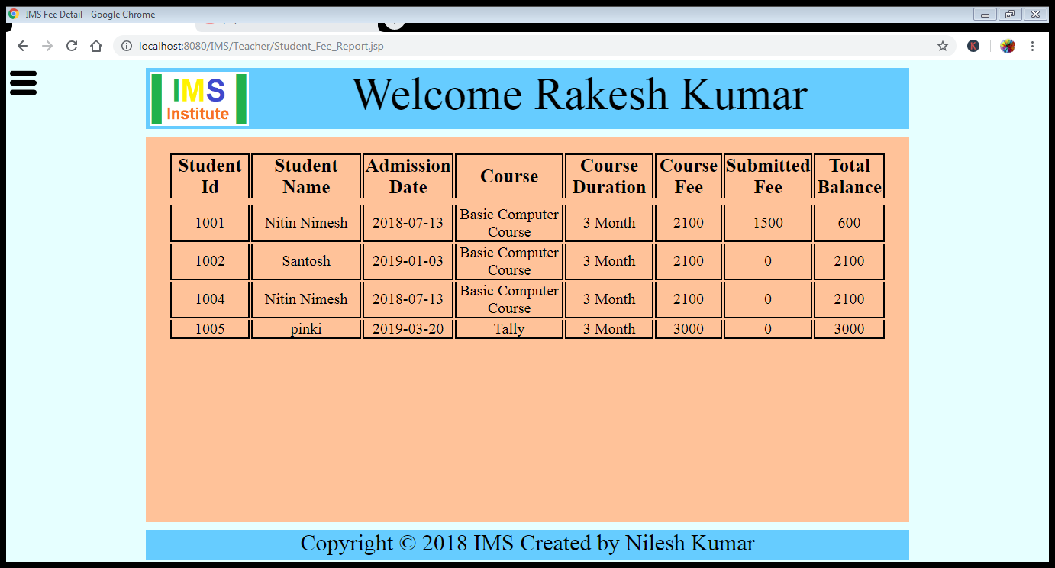

Click on take student fee it will open Take_Student_Fee.jsp and it is already shown in previous images.

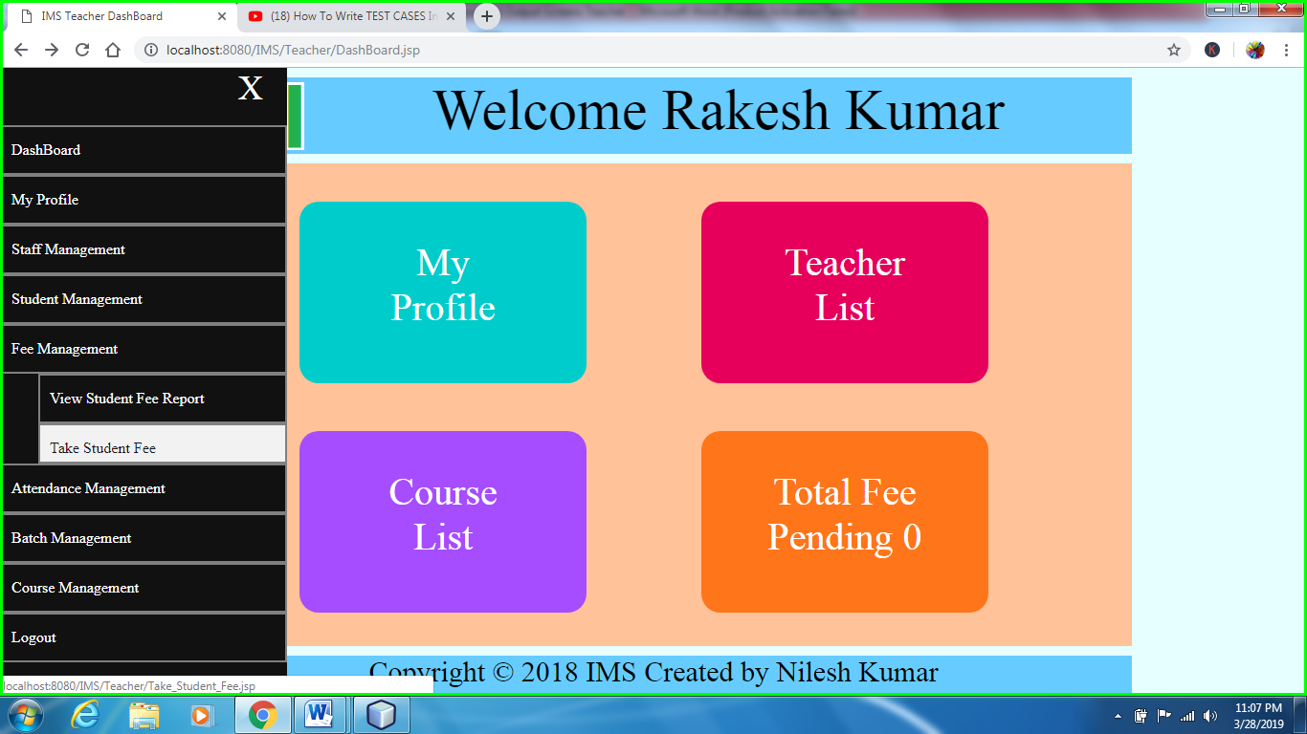

Attendance Management (view Attendance) and it will open View_Attendance.jsp page

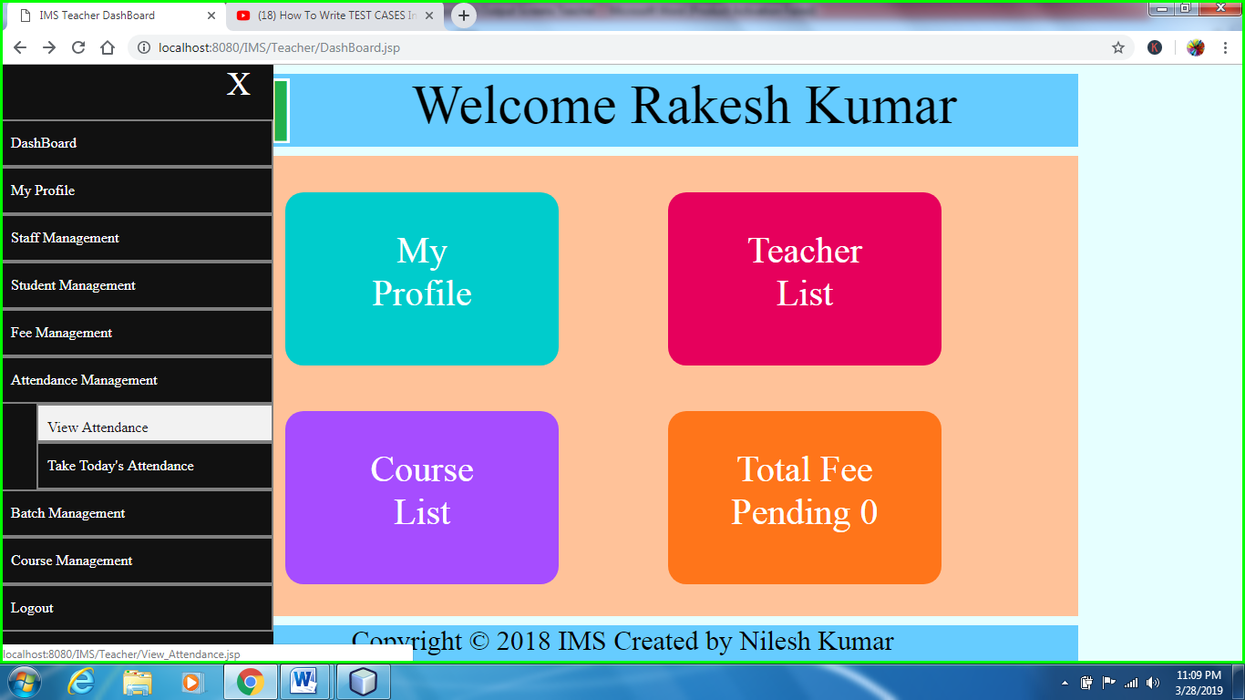

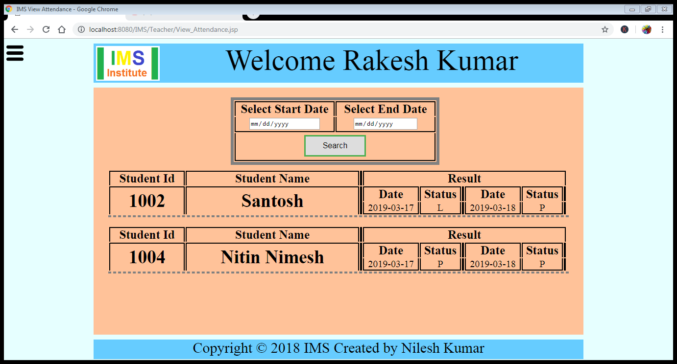

Take today’s attendance and it will open Take_Attendance.jsp page.

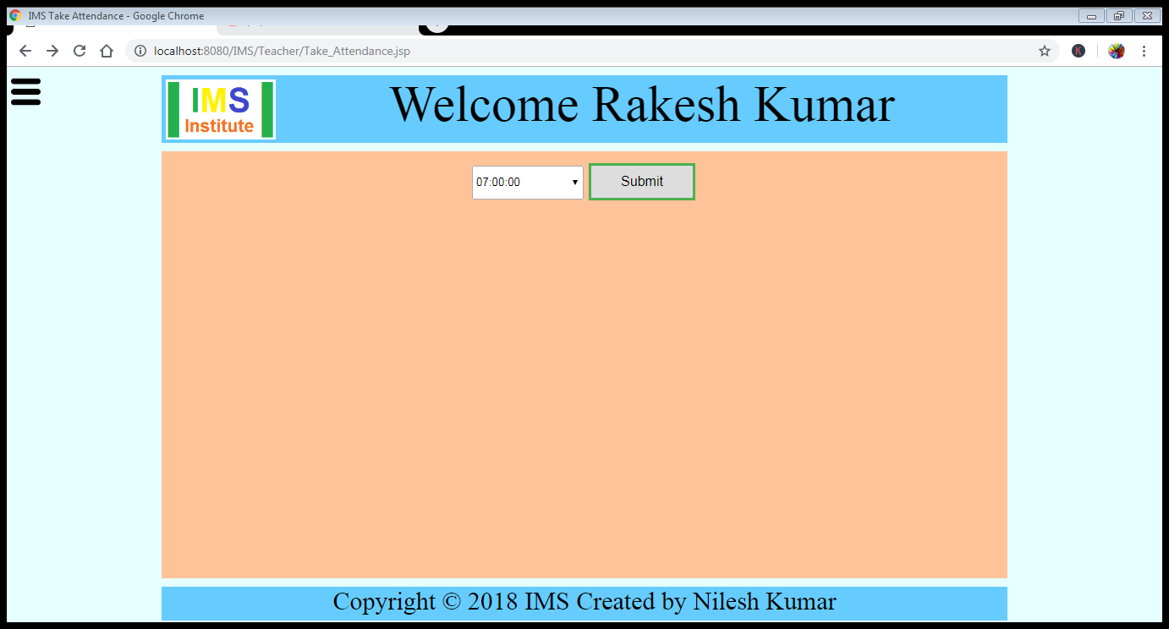

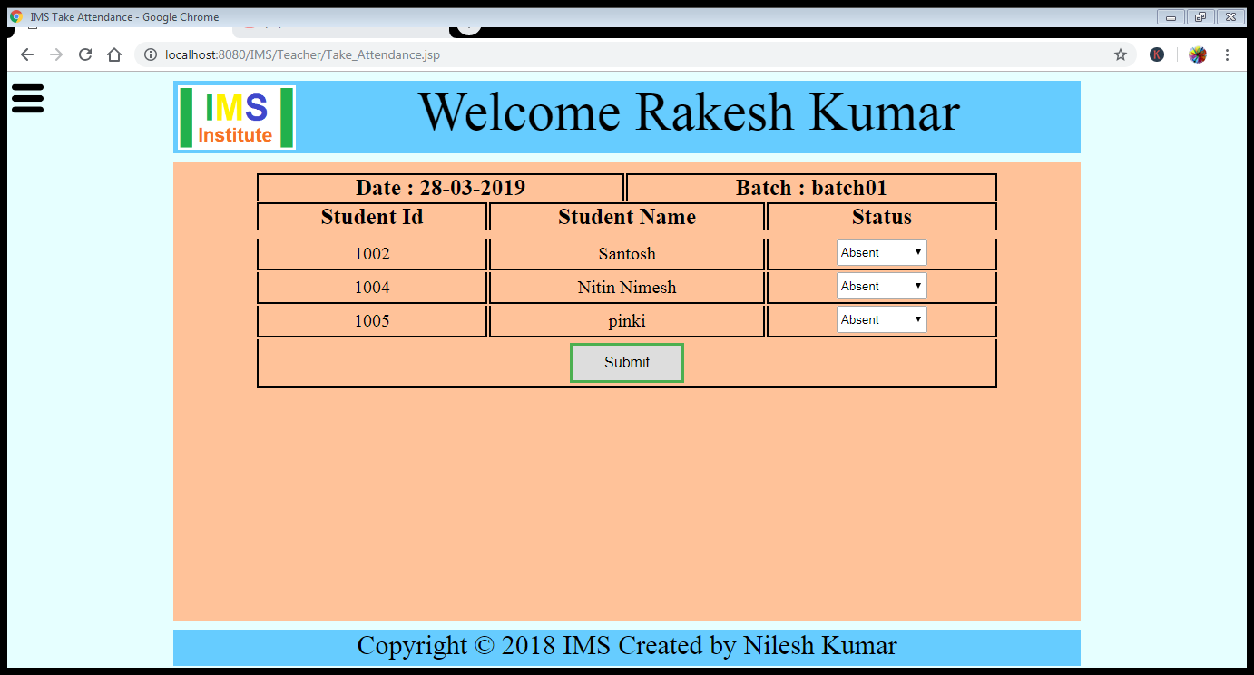

When we click on Submit button the data will send to the Store_Attendance.jsp and stored in database.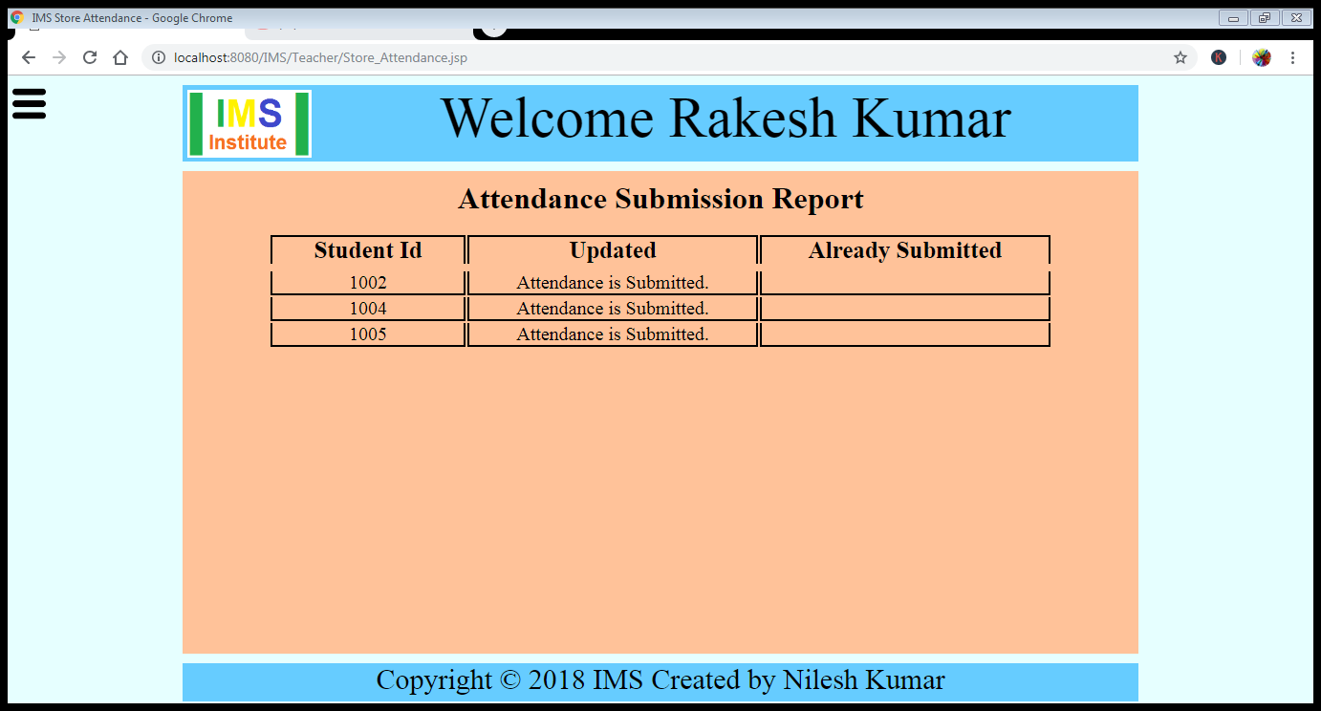

Click on view running batch and it will open Batch_List.jsp

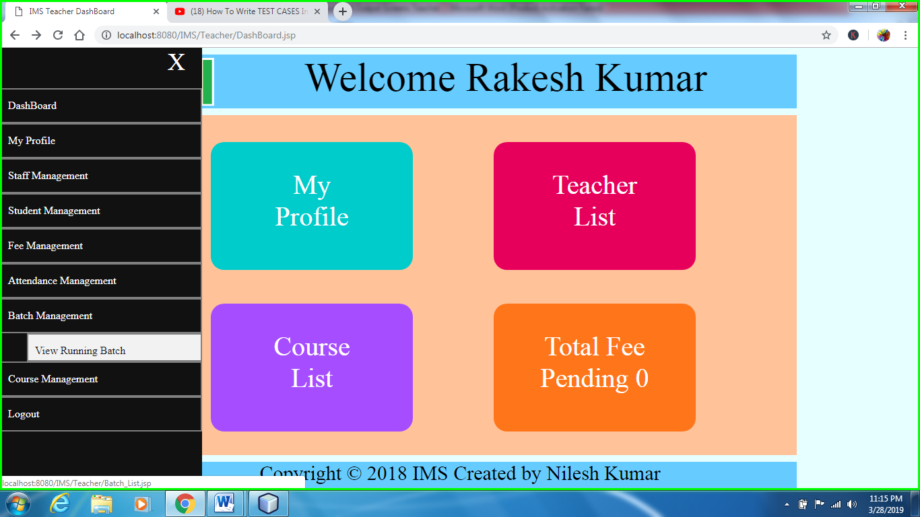

Course management (View Course Detail) and it will open Course_List.jsp

